Supplementary material



Scale Justification:

3.1 is identical with 2.4, because in 2.4 there is a threat, whereas in 3.1 there is no threat but only a requirement, but the ego has no strategy and fails.

Then follows 3.2, because here the dream ego does not succeed in coping with the requirements; only in the next step follows 2.5, because the overcoming of the threat, psychologically speaking the liberation of the ego from the influence of the complex, represents a more mature step.

Then follows 3.3, because here the requirements are also successfully mastered.

Type 4 is more mature than type 3, insofar as in type 3 that ego is still subject to the demands of another, while in type 4 it pursues its own intentions and plans. However, 4.1 is less mature than 3.3 in that while there is an approach of ego initiative here, this activity is still completely constrained.

4.2 is on the same level as 3.3 because although there is an approach of own initiative here, it still cannot be implemented.

In Type 5, the situation has changed in that the ego now seeks relationships with other people, which psychologically can be seen as the equivalent of more mature object relationships. However, subtypes 5.1 and 5.2 must be considered less mature than 4.5, because in the latter contact with others still fails.

In type 6, an even greater maturity of the ego is present, insofar as here that ego is satisfied with its autonomy independent of contact with others. 6.1, however, is still below 5.3, because here, too, the shaping of the situation with the others does not succeed, in contrast to 5.3. 6.2 is on the same level as 5.3, because here the shaping of the togetherness with others by the ego succeeds, even if with aggressive means.

Amalia X

|  |  |  |
| --- | --- | --- |
| R2 | 0,0879 | #DIV/0! |
| r | 0,2965 | #DIV/0! |
| n | 95 | 95 |
| t | 2,9944 | #DIV/0! |
| df | 93 | 93 |
|  |  |  |
| p | 0,003523279 | #DIV/0! |



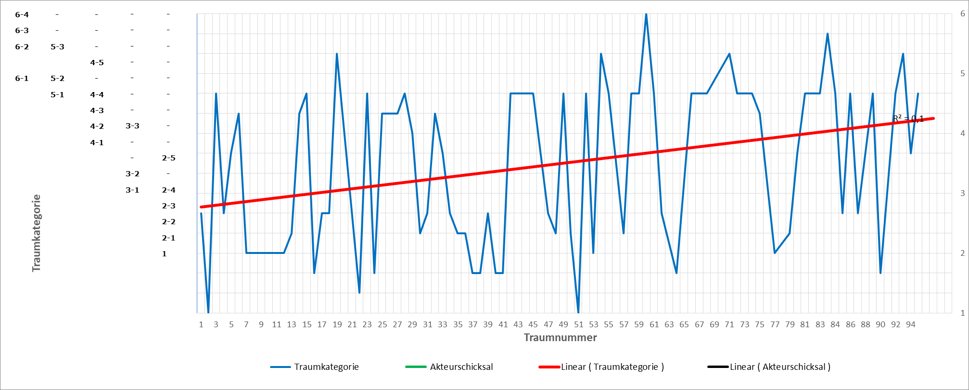

|  |  |  |
| --- | --- | --- |
| ***Table***  *Kendall rank coefficients* | | |
| *Dream series* | *Coefficient* | *p-value* |
| 1 | 0.2165328 | 0.3204 |
| 2 | 0.2262779 | 0.3246 |
| 3 | 0.1107486 | 0.4472 |
| 4 | 0.2034801 | 0.2023 |
| 5 | 0.305108 | 0.205 |
| 6 | 0.1047982 | 0.5329 |
| 7 | -0.04877565 | 0.7378 |
| 8 | 0.368035 | 0.1475 |
| 9 | 0.1445608 | 0.445 |
| 10 | 0.1261144 | 0.429 |
| 11 | -0.4305385 | 0.0305* |
| 12 | -0.4305385 | 0.0305* |
| 13 | 0.1129131 | 0.4611 |
| 14 | -0.186321 | 0.3148 |
| 15 | 0.6048147 | 0.007073** |
| 16 | 0.6666667 | 0.3333 |
| 17 | 0 | 1 |
| 18 | 0.19518 | 0.5434 |
| 19 | 0.4001634 | 0.14 |
| 20 | 0.1906925 | 0.5208 |
| 21 | 0.1241322 | 0.4282 |
| 22 | 0.1973855 | 0.236 |
| 23 | 0.2614882 | 0.3567 |
| 24 | 0.2981424 | 0.4206 |
| 25 | 0.1135835 | 0.5265 |
| 26 | 0.2760262 | 0.276 |
| 27 | 0.3048029 | 0.1561 |
| 28 | 0.3215879 | 0.1533 |
| 29 | 0.230288 | 0.248 |
| 30 | -0.1514189 | 0.4686 |
| 31 | 0.4889012 | 0.05557 |
| 32 | 0.2444456 | 0.07959 |
| 33 | 0.3234216 | 0.08819 |
| 34 | 0.1611646 | 0.5952 |
| 35 | 0.1193525 | 0.643 |
| 36 | 0.4642383 | 0.09831 |
| 37 | 0.0860663 | 0.8216 |
| 38 | -0.4 | 0.4833 |
| 39 | 0.1143324 | 0.6733 |
| 40 | 0.2345088 | 0.3148 |
| 41 | -0.2300219 | 0.3653 |
| 42 | 0.6481812 | 0.01902* |
| 43 | 0.5261368 | 0.06309 |
| *Note: *p < .05, **p < .01* | | |

Failed case:



Significant negative rank correlation for case F12; * *p* < .05.